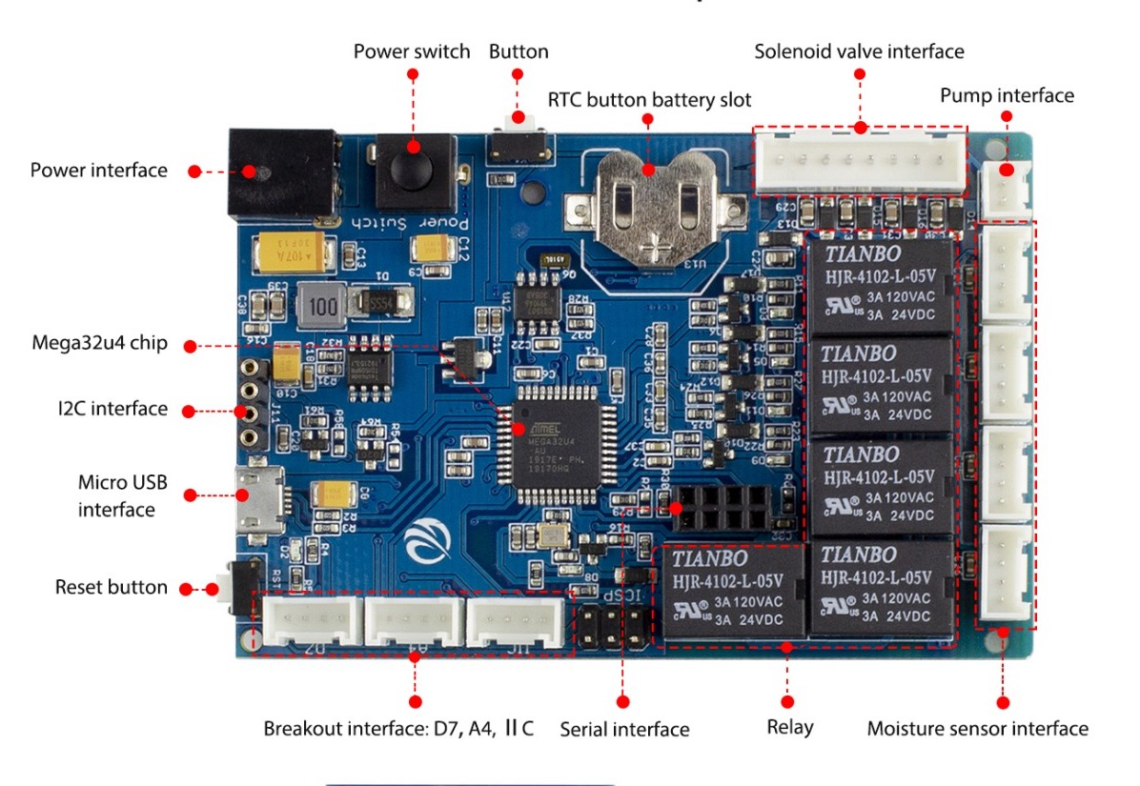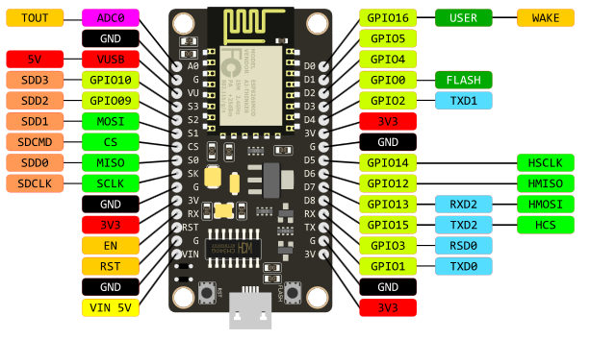

**Parts list:**

[Elecrow Plant Watering System](https://www.amazon.com/gp/product/B07LCNKC6N/ref=ppx_yo_dt_b_asin_image_o07_s00)

[ESP8266 Node MCU](https://www.amazon.com/HiLetgo-Internet-Development-Wireless-Micropython/dp/B010N1SPRK/ref=sr_1_2_sspa)

[Bi-directional Logic Level Converter](https://www.amazon.com/gp/product/B014MC1OAG/ref=ppx_yo_dt_b_asin_title_o04_s00)

# [Grove - 4 Pin Female Jumper Cable](https://www.amazon.com/gp/product/B01EX9LTMQ/ref=ppx_yo_dt_b_asin_title_o06_s00)

# [Ultrasonic Module HC-SR04](https://www.amazon.com/gp/product/B01JG09DCK/ref=ppx_yo_dt_b_asin_title_o09_s00)

**Connections:**

|  |  |  |  |
| --- | --- | --- | --- |
| **Arduino** | **ESP8266** | **Level Conv** | HC-SR04 |
| 3.3V (serial Interface) | V3 | LV |  |
| GND (serial Interface) | GND |  |  |
| VCC/GND (IIC) |  | HV/GND |  |
| TX (serial Interface) |  | HV3 |  |
|  | D6 | LV3 |  |
| RX (serial Interface) |  | HV1 |  |
|  | D5 | LV1 |  |
| D7 |  |  | Trig |
| A4 |  |  | Echo |
| VCC |  |  | VCC |
| GND |  |  | GND |
|  |  |  |  |
|  |  |  |  |